Idera
Managing your Windows World
SQL diagnostic manager
Quick Start

Idera – a division of BBS Technologies, Inc.,DTx, IntelliCompress, Point admin toolset, Pointbackup, Pointcheck, PowerShellPlus, SharePoint backup, SharePoint performance monitor, SQLcheck, SQL change manager, SQLconfig, SQL comparison toolset, SQL compliance manager, SQLcompliance, SQLcm, SQL defrag manager, SQL diagnostic manager, SQLdm, SQL mobile manager, SQLpermissions, SQLsafe, SQLsafe Freeware Edition, SQLsafe Lite, SQLscaler, SQLschedule, SQL schema manager, SQLsecure, SQLsmarts, SQLstats, SQLtool, SQL toolbox, SQL virtual database, SQLvdb, virtual database, Idera, BBS Technologies and the Idera logo are trademarks or registered trademarks of BBS Technologies, Inc., or its subsidiaries in the United States and other jurisdictions. All other company and product names may be trademarks or registered trademarks of their respective companies. © 2010 BBS Technologies, Inc., all rights reserved.
THIS DOCUMENT AND THE SOFTWARE DESCRIBED IN THIS DOCUMENT ARE FURNISHED UNDER AND ARE SUBJECT TO THE TERMS OF A LICENSE AGREEMENT. EXCEPT AS EXPRESSLY SET FORTH IN SUCH LICENSE AGREEMENT, BBS TECHNOLOGIES, INC., PROVIDES THIS DOCUMENT AND THE SOFTWARE DESCRIBED IN THIS DOCUMENT “AS IS” WITHOUT WARRANTY OF ANY KIND, EITHER EXPRESS OR IMPLIED, INCLUDING, BUT NOT LIMITED TO, THE IMPLIED WARRANTIES OF MERCHANTABILITY OR FITNESS FOR A PARTICULAR PURPOSE. SOME STATES DO NOT ALLOW DISCLAIMERS OF EXPRESS OR IMPLIED WARRANTIES IN CERTAIN TRANSACTIONS; THEREFORE, THIS STATEMENT MAY NOT APPLY TO YOU. YOU ARE ENCOURAGED TO READ THE LICENSE AGREEMENT BEFORE INSTALLING OR USING THIS DOCUMENTATION OR SOFTWARE.
Some companies, names, and data in this document are used for illustration purposes and may not represent real companies, individuals, or data.
This document could include technical inaccuracies or typographical errors. Changes are periodically made to the information herein. These changes may be incorporated in new editions of this document. BBS Technologies, Inc., may make improvements in or changes to the software described in this document at any time.
© 2003-2010 BBS Technologies, Inc., all rights reserved.
U.S. Government Restricted Rights: The software and the documentation are commercial computer software and documentation developed at private expense. Use, duplication, or disclosure by the Government is subject to the terms of the BBS Technologies, Inc., standard commercial license for the software, and where applicable, the restrictions set forth in the Rights in Technical Data and Computer Software clauses and any successor rules or regulations.
About Idera
At Idera, we deliver a new generation of tools for managing, administering, and securing your Microsoft Windows Servers, including SQL Server, SharePoint, PowerShell and Microsoft Dynamics. We employ numerous industry experts worldwide who are devoted to bringing proven solutions to you, the administrator. Idera provides solutions that help you ensure server performance and availability and reduce administrative overhead and expense. Our award-winning products install in minutes, configure in hours and deploy worldwide in days. Idera is a Microsoft Gold Certified Partner headquartered in Houston, Texas, with offices in London, UK, Melbourne, Australia, and Sao Paulo, Brazil.
Idera Products
Our about are engineered to scale – from managing a single server to enterprise deployments with thousands of servers. Idera products combine ease of use with a design to install in minutes, configure in hours, and deploy worldwide in days. To learn more about Idera products, visit www.idera.com/products.
Contacting Idera
Please contact us with your questions and comments. We look forward to hearing from you. For support around the world, please contact us or your local partner. For a complete list of our partners, please see our Website.
Sales | 713.523.4433  1.877.GO.IDERA (464.3372)  (only in the United States and Canada)
Sales Email | Hsales@idera.comH
Support | 713.533.5144  1.877.GO.IDERA (464.3372)  (only in the United States and Canada)  Hwww.idera.com/supportH
Support Email | Hsupport@idera.comH
Website | www.idera.com

Contents
Welcome to SQL diagnostic manager 3
SQLdm Architecture 4
Deployment Scenarios 4
SQLdm Components 5
Authentication in SQLdm 5
General Requirements 6
Trial Requirements 6
Production Requirements 7
Trial Install 8
Add a SQL Server Instance to Monitor 10
Use SQLdm to Resolve Specific Issues 11
Detect Potential SQL Server Problems25Bk 13
Diagnose SQL Server Problems 14
Improve Database Performance 15
Use Reports to Track Performance 16
Installing SQLdm in a Windows Server 2003 Clustered Environment 17
Installing SQLdm in a Microsoft Server 2008 Clustered Environment 18

Welcome to SQL diagnostic manager
SQL diagnostic manager (SQLdm) provides an unprecedented level of diagnostic information on the health, performance, and status of SQL Server instances across your environment. You can view, diagnose, and report on critical performance statistics from a central point of control.
Using a unique agentless architecture, SQLdm gathers diagnostic information in real time, keeping database administrators and managers informed by providing customized alerts. Easy to install and use, SQLdm is an indispensable SQL Server management tool that benefits both experienced and junior database administrators.

How SQLdm Helps You
Whether you need immediate diagnostic information or want to gather data for long-term capacity planning, you can use SQLdm to help:
- Increase SQL Server availability
- Provide a comprehensive view of current performance
- Provide continuous, unattended monitoring
- Store data in the centralized SQLdm Repository database
- Improve the productivity of both skilled and novice database administrators
With clear, easy-to-understand charts and reports, you can track standard SQL Server performance metrics, trend historical performance data over time, and proactively identify potential performance problems.

SQLdm Architecture
SQLdm has a 3-tier system that includes a centralized database for historical data collection and reporting. You can install multiple SQLdm Consoles to communicate with the SQLdm Collection and Management Services and the central Repository. The following diagram displays the interaction between each SQLdm component.
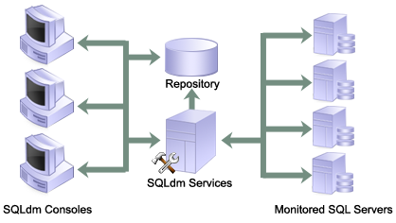

Deployment Scenarios
Before you begin installing SQLdm, it is important to consider your deployment choices. The following deployment strategies are recommended.

Trial Deployment
A trial deployment installs all SQLdm components on the same computer. A trial deployment can monitor SQL Server instances anywhere on your network. This document assumes that you performing a trial deployment.

Production Deployment
A production deployment installs each SQLdm component on a separate, dedicated computer. This deployment ensures stable performance and availability as your environment grows and your monitoring needs change.

SQLdm Components
SQLdm consists of a light, unobtrusive architecture that easily runs in your SQL Server environment with minimal configuration. All SQLdm components run outside and separate from SQL Server processes.

SQLdm Console
Use the SQLdm Console to:
- View real-time status
- Configure alert notifications on specific metric thresholds at the server and database levels
- View historical reports and manage your To Do list
- Perform administrative functions
The SQLdm Console retrieves historical information directly from the SQLdm Repository. All real-time requests use the SQLdm services to poll the monitored SQL Server.

SQLdm Services
SQLdm has two centralized services, the Management Service and the Collection Service. These two services reside on the same computer.
The Management Service performs the following primary functions:
- Provides real-time data to the SQLdm Console
- Receives historical data from the Collection Service for storage in the Repository
- Raises alerts and sends alert notifications
The Collection Service performs on-demand and scheduled collection from the monitored SQL Servers.

SQLdm Repository
The SQLdm Repository is a centralized SQL Server database that stores collected metrics on a scheduled basis, historical data, and alerts information. The SQLdm Repository also stores configuration information, such as the credentials used to monitor a registered SQL Server instance.

Authentication in SQLdm
SQLdm uses the same types of authentication available in the SQL Server security model. When specifying account credentials for the SQLdm services, you can use Windows Authentication or SQL Server Authentication.
When considering which authentication to use, keep in mind that SQL Server Authentication is required when no domain trust exists between the SQLdm Services computer and the computers hosting the monitored SQL Server instances. For example, if the monitored SQL Server instances are located in an untrusted domain or behind a firewall, you must use SQL Server Authentication to successfully deploy SQLdm. In this case, you must use the sa account or a SQL Server login that has System Administrator permissions.
For more information about these authentication types and the SQL Server security model, see the Microsoft SQL Server Books Online.

General Requirements
The following requirements apply for all SQLdm components.
Type | Requirement
CPU | 2.0 GHz or higher
Memory | 1 GB
32-bit Operating System | Windows 2000 SP4 or later  Windows Server 2003 SP2 or later  Windows XP SP2 or later  Windows Vista Business and Enterprise  Windows 7  Windows Server 2008 SP1 or later  .Net 2.0 and MDAC 2.8
64-bit Operating System | Windows Server 2003 SP1 (X64 or Itanium 2)  Windows XP Professional X64  Windows 7  Windows Server 2008 or later  Windows Server 2008 R2  Windows Vista Business and Enterprise  .Net 2.0 and MDAC 2.8
Port Access | 5166, 5167
Client Browser | Internet Explorer 7.0 or later

Trial Requirements
Consider the following requirements when installing all SQLdm components on one computer.
Type | Requirement
SQL Server Standard or Enterprise Edition | SQL Server 2000 SP4 or later  SQL Server 2005 SP1 or later  SQL Server 2008 or later
Hard Disk Space | 200 MB for all SQLdm components
Windows Permissions | Your Windows Logon account has local Administrator permissions
SQL Server Privileges | Either a Windows user account or SQL Server login that has System Administrator privileges on the monitored SQL Server instance
Production Requirements
Consider the following requirements when installing SQLdm in an environment where the components are on separate computers.

SQLdm Console
Type | Requirement
Disk Space | 40 MB
SQL Server Permissions | Your Windows logon account has Read access to the SQLdm Repository. You can specify a SQL Server login instead.

SQLdm Services
Type | Requirement
Disk Space | 50 MB
Collection Service Permissions | System Administrator privileges on the monitored SQL Server instances
Management Service Permissions | Read and Write privileges on the SQLdm Repository database

SQLdm Repository
Type | Requirement
Disk Space | 1GB to 3GB for one year of data per monitored SQL Server instance
SQL Server Standard or Enterprise Edition | SQL Server 2000 SP4 or later  SQL Server 2005 SP1 or later  SQL Server 2008 or later

Monitored SQL Server Instances
Type | Requirement
SQL Server Standard or Enterprise Edition | SQL Server 2000 SP4 or later  SQL Server 2005 SP1 or later  SQL Server 2008 or later
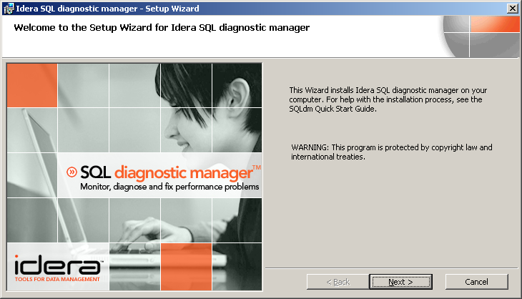
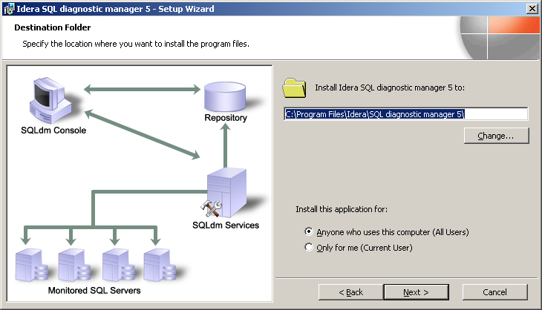
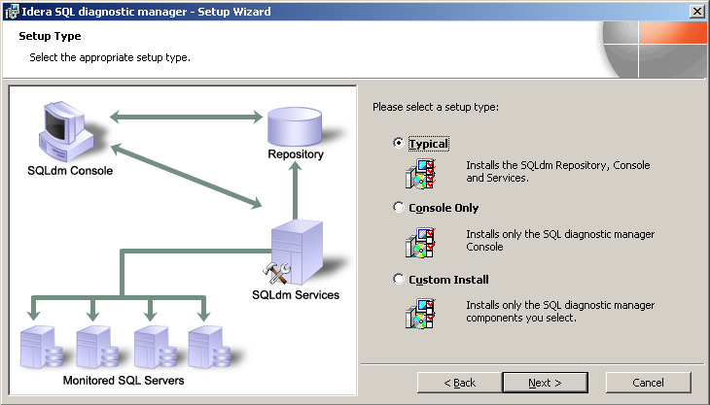
Trial Install
This procedure guides you through a trial install of SQLdm. A trial install sets up all SQLdm components on the same computer. Use this procedure for first time installs and evaluation installs.
Start your install
You can install SQLdm on any computer that meets or exceeds the product requirements.
To start installing SQLdm:
- Log on with an administrator account to the computer on which you want to install SQLdm.
- Run Setup.exe in the root of the installation kit.
- Click INSTALL on the Welcome window, and then click INSTALL SQL diagnostic manager on the Install window.
- On the Welcome window of the setup program, click Next.
- Review the license agreement, if you accept this license agreement, click I accept the terms of this license agreement, and then click Next.
Where do you want to install SQLdm and who will use the product on this computer?
You can use the default install location or specify a different path. For your first install, we recommend using the default location.
Choose whether you want any user or only the current user to access this application, and then click Next.
Begin configuring your install
For your first install, we recommend using the Typical setup type. This type ensures you install and configure all required SQLdm components so you can immediately begin monitoring your SQL Server environment.
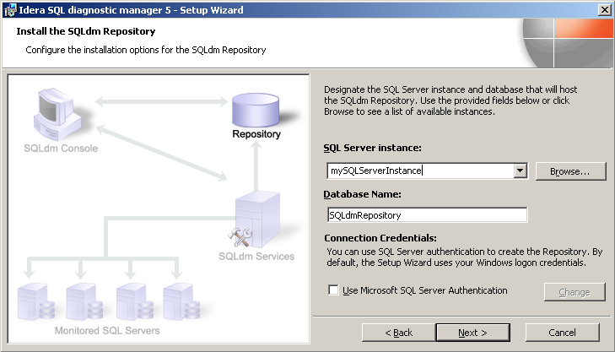
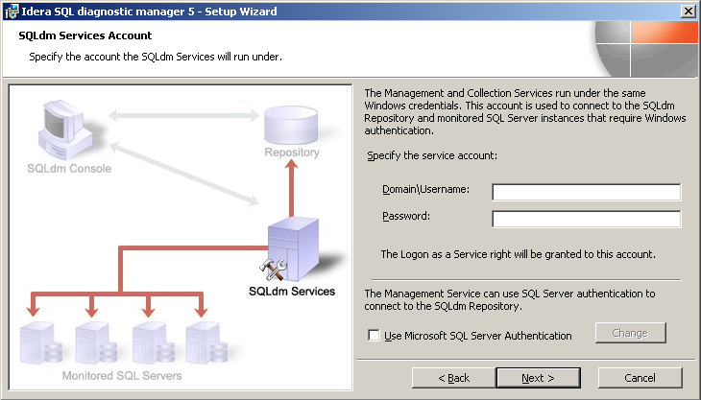
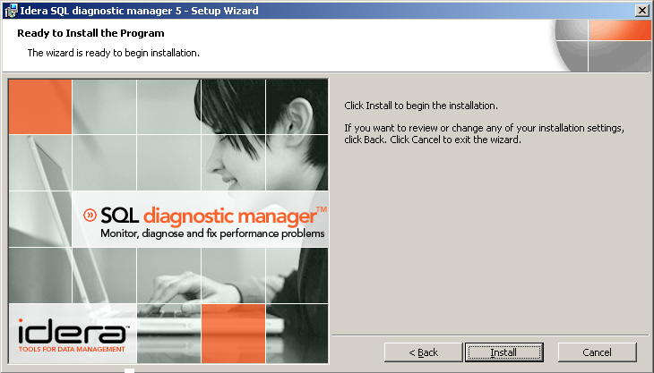
Which SQL Server instance do you want to use for the Repository databases?
The SQLdm Repository is where the collected data, alert information, and alert configuration settings are stored.
To specify the SQL Server instance to install the SQLdm Repository on:
- Click Browse.
- Select the SQL Server instance you want to use. The SQL Server window lists SQL Server instances provided by your domain controller. If you do not see your SQL Server instance in the list, enter the host name and instance in the space provided.
- If your SQL Server environment uses SQL Server Authentication, select the checkbox and click Change to enter SQL Server credentials. By default, SQLdm uses your Windows credentials when connecting to the Repository.
- Click Next.
Which Windows user account do you want to use for the service account?
SQLdm uses the service account to communicate between the SQL Server instance and the SQLdm Repository.
To specify a service account:
- Enter credentials and passwords in the appropriate fields.
- Click Next. SQLdm will verify the connection before continuing.
Complete the install
Click Install to indicate that you are ready to complete your install with the configurations you specified.
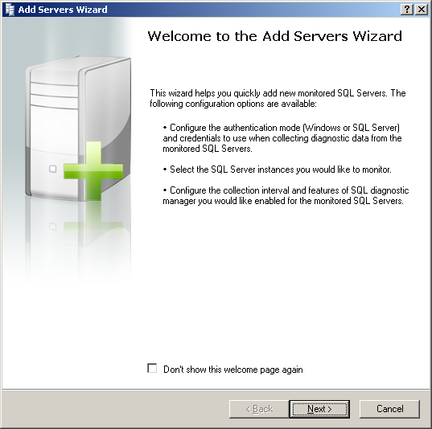
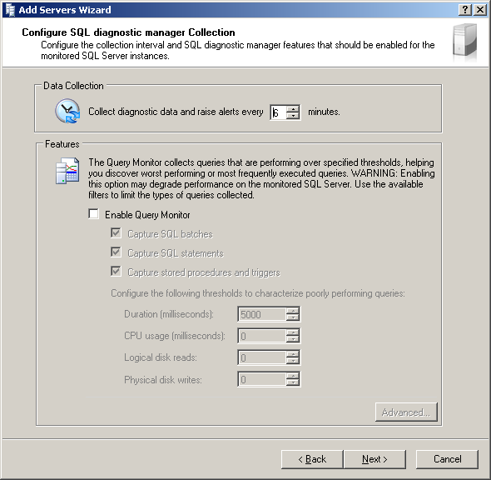
Add a SQL Server Instance to Monitor
When you run SQLdm for the first time, the Welcome window displays so you can quickly add SQL Server instances before continuing. Click Add Servers Wizard (Recommended) to start the registration process.
Select the authentication type and SQL Server instances to monitor
To select the authentication type and SQL Server instances:
- Click Next on the Welcome to the Add Servers Wizard window.
- Select the authentication that SQLdm Collection Service should use to collect diagnostic data from the SQL Server instance.
- Click Next.
- Select the SQL Server 2000, SQL Server 2005, and SQL Server 2008 instances you want to monitor. If you do not see the name of the SQL Server instance you want to add, enter the host and instance name in the space provided.
- Click Next.
Configure the collection settings
The Configure SQL diagnostic manager Collection window allows you to select:
- How often diagnostic data should be collected (and how often the associated alert thresholds should be checked)
- Whether or not you want to enable the Query Monitor to monitor a known query issue. For your first SQL Server installation, the default settings are recommended. These settings can be edited later from within the SQLdm Console.
Click Next to add tags to your SQL Server instance.
Select tags for this instance
The Select Tags window allows you to add or assign tags to the SQL Server instance you are registering. Tags allow you to customize how you organize and manage your monitored servers. For more information about tags, see the online Help.
Click Finish to add your SQL Server instance to SQLdm for monitoring

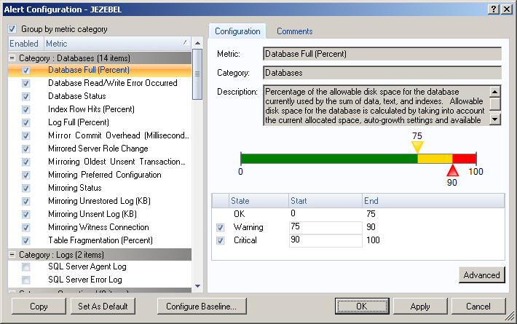
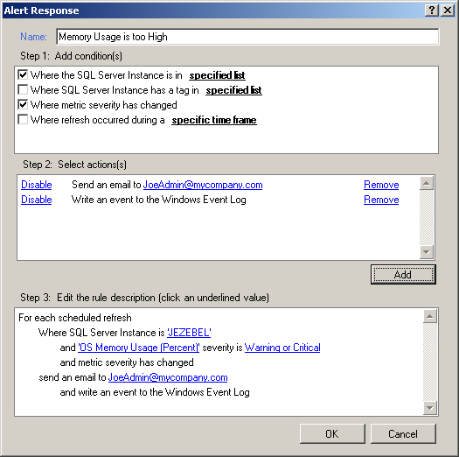

Use SQLdm to Resolve Specific Issues
SQLdm provides you the opportunity not only monitor the status of your SQL Server environment, but detect and resolve issues before they reach a critical status.
In this example, we are configuring an alert and the associated notification rules.

Configure alert settings
Although SQLdm has preset alert thresholds, you should configure alert threshold levels that help you anticipate oncoming problems with your SQL Server instances.
To configure alert thresholds:
- Right-click your SQL Server instance and select Configure Alerts.
- Scroll down to OS Used Memory (Percent).
- Adjust the thresholds as needed.
- Click OK.

Set up an alert response to distribute alerts
The Alert Actions and Responses window allows you to add new notification rules and modify or disable existing rules. You can set up an unlimited amount of rules to designate when and how alert responses occur, and who should receive them. In this example, we are setting up an email notification.
To set up a notification rule:
- Select Tools > Alert Actions and Responses from the toolbar menu.
- Click Add.
- Click Add in Step 2 of the Alert Response window.
- Check the New SMTP Action Provider option. When asked to create an SMTP Notification Provider before continuing, click OK.

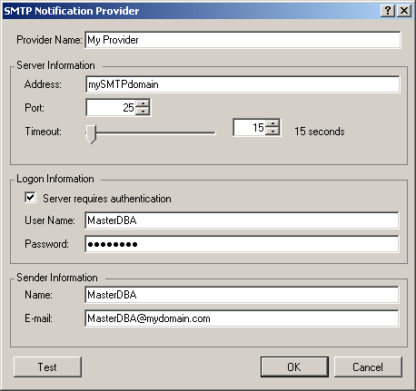

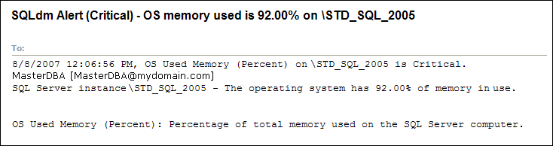

Set up your notification provider
The SMTP Notification Provider window allows you to configure the way email notifications are sent through your email server. Once configured, alerts associated with your notification rule will be sent to the email address provided.
To configure the SMTP Notification:
- Enter the SMTP address you will use to send emails in the address field
- If required, check the Server requires authentication box.
- Enter the user name and password of the account you want SQLdm to send emails from.
- Enter the name and email address to show in the From field of the notification email.
- Click Test.
- Enter your email address to send the test email to.
- Verify the email arrived.
- Click OK.

Select who should receive the alert notification
The next step in the Notification process is to select who should receive the email notification.
To select the SMTP Destination:
- Click the recipient link on the Notification Rule window.
- Select the email provider you entered from the drop-down list.
- Enter the email address or addresses you want the alert to be sent to in the To field. If there are multiple recipients, divide the email addresses using either a comma or semi-colon.
When an email alert is sent, the title includes the threshold level, the SQL Server instance name, the metric alerted on, and the number associated with the metric.

Review the alert history and To Do lists
The Alerts view allows you to review and sort alerts over a period of time, while the To Do view allows you to review and edit the status of the To Do items created in the alert notification process.

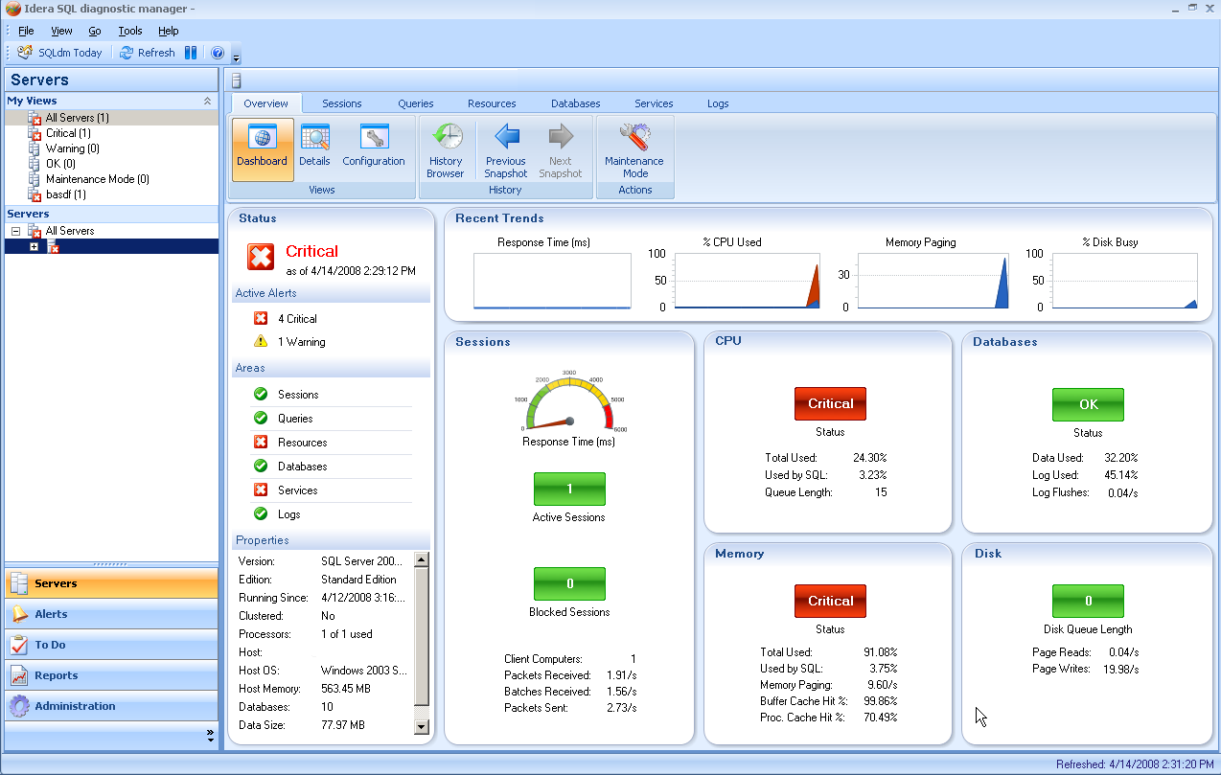

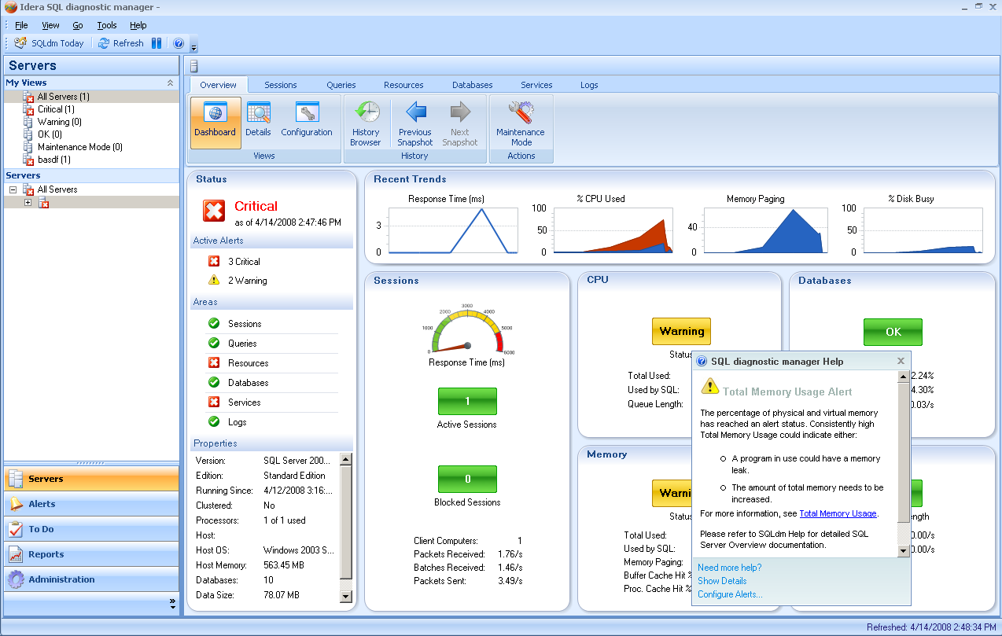

Detect Potential SQL Server Problems25Bk
The Server Summary view contains a graphical representation of the activity on your SQL Server instance. The Server Summary view is structured to not only display the status of your SQL Server instance, but allows you to diagnose where problems originate. The Server Overview allows you to:
- Monitored Blocked and Blocking Sessions
- Capture Long Running Queries
- Diagnose Resource Bottlenecks
To open the Server Summary view, select a monitored SQL Server instance from the Servers Tree.

Quickly detect performance bottlenecks as they occur
The colors used for the metrics on the Server Overview indicate status levels. In this example, the bottom spinner in the Resources section is yellow. This indicates that a Memory metric has crossed a warning threshold.

Find possible causes for the bottlenecks
Pop-up help (available by clicking a metric) is associated with all the metrics on the Server overview. Pop-up help provides descriptions of the monitored metric and when there is an alert the pop-up Help gives you advice on how to fix the issue.
In this example, the pop-up tells us that there is an alert associated with the Total Memory Used metric and that we should go to the Memory view on the Resources tab to diagnose the issue.
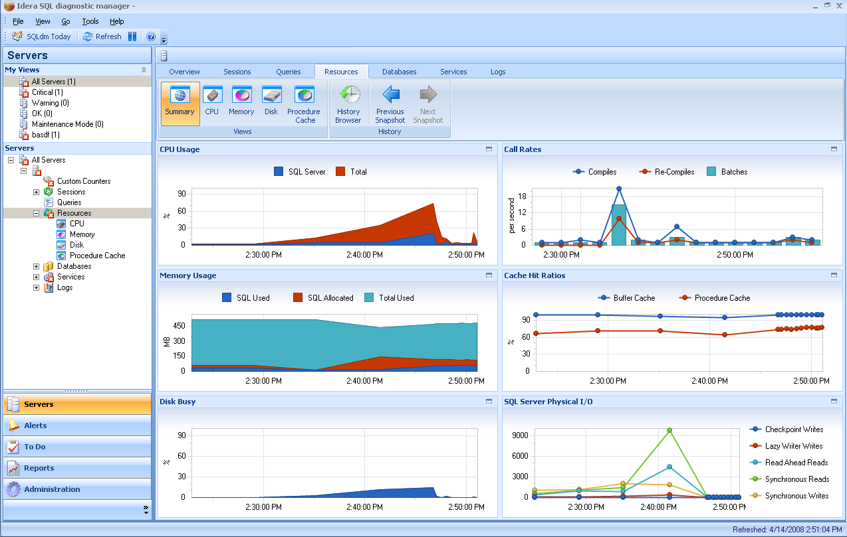

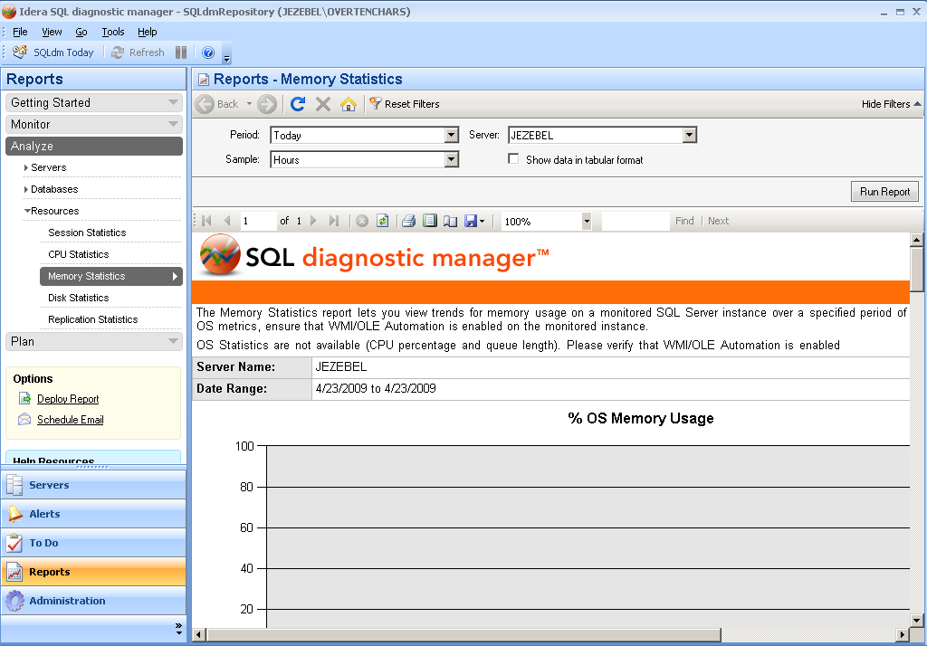

Diagnose SQL Server Problems
There are seven tabs across the top of the Server Summary view: Overview, Sessions, Queries, Resources, Databases, Services, and Logs. Select the Resources tab and click the Memory view.

View memory issues using the Memory view
The Memory view contains six charts that display important memory-related charts. These charts include the Memory Usage, Paging, Memory Areas, Cache Hit Ratios, Buffer Cache, and Procedure Cache charts.
In this example, the Memory Usage chart displays the memory used by SQL Server, the memory allocated to SQL Server, and the Total Memory being used.
Looking at this chart, we can determine that the reason the Total Memory alert was generated is not a result of SQL Server using too much memory, but that some other process or processes are taking up a very large percentage of the available memory.

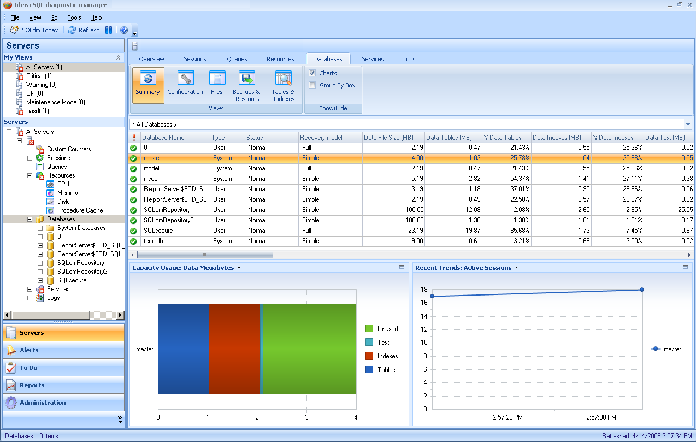

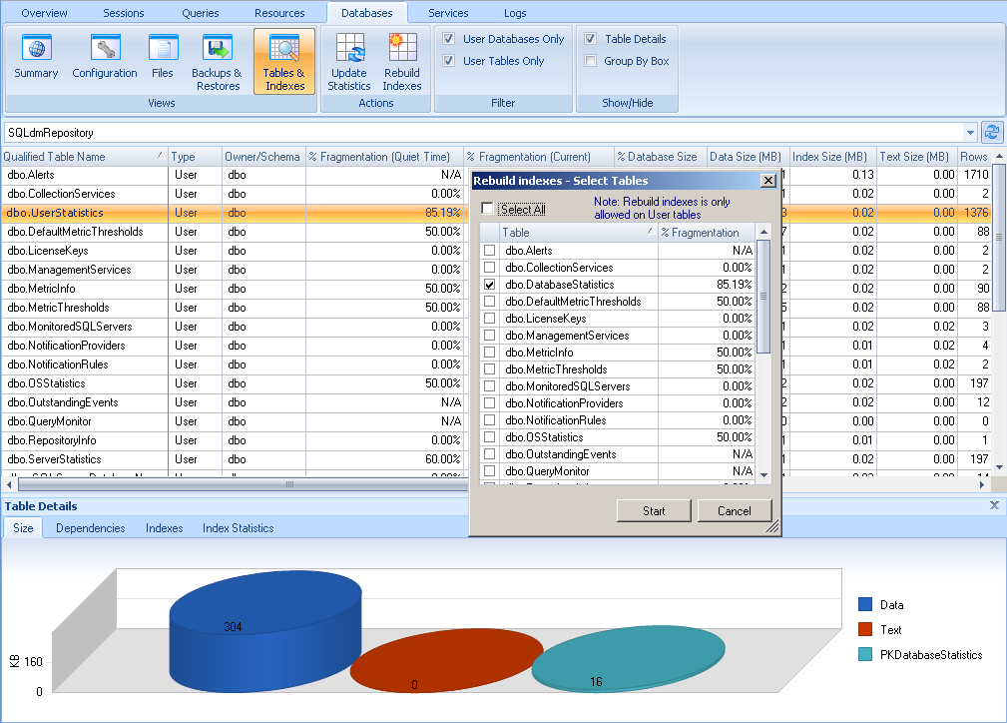

Improve Database Performance
The Databases tab allows you to view the overall health of the databases on your monitored SQL Server instance. The views on this tab include a general summary, configuration settings, file statistics, the backup and restore history, and table and index statistics.

Spot potential problems
In this example, we notice that one of our databases has a warning status on the Database Summary view.
To spot a database issue:
- Place cursor over the warning icon in the Status column.
- An alert message appears telling us that there is a table in the database that has a high fragmentation level.
- Click the Tables & Indexes view to see Table and Index statistics.
- Notice that several tables are at 50 percent fragmentation, and one is even at 85 percent fragmentation level. This exceeds the alert thresholds on the SQL Server instance and requires your attention.

Rebuild your indexes to reduce fragmentation levels
As tables become more fragmented, database performance declines. SQLdm includes the ability to rebuild indexes to quickly reduce the amount of table fragmentation.
To rebuild indexes:
- Select a table in the list.
- Click Rebuild Indexes.
- Select tables you want to rebuild from the list on the Rebuild indexes dialog.
- Click Start to begin rebuilding the indexes.
When the rebuilding process has been completed, a new column will appear displaying the new fragmentation percentage.
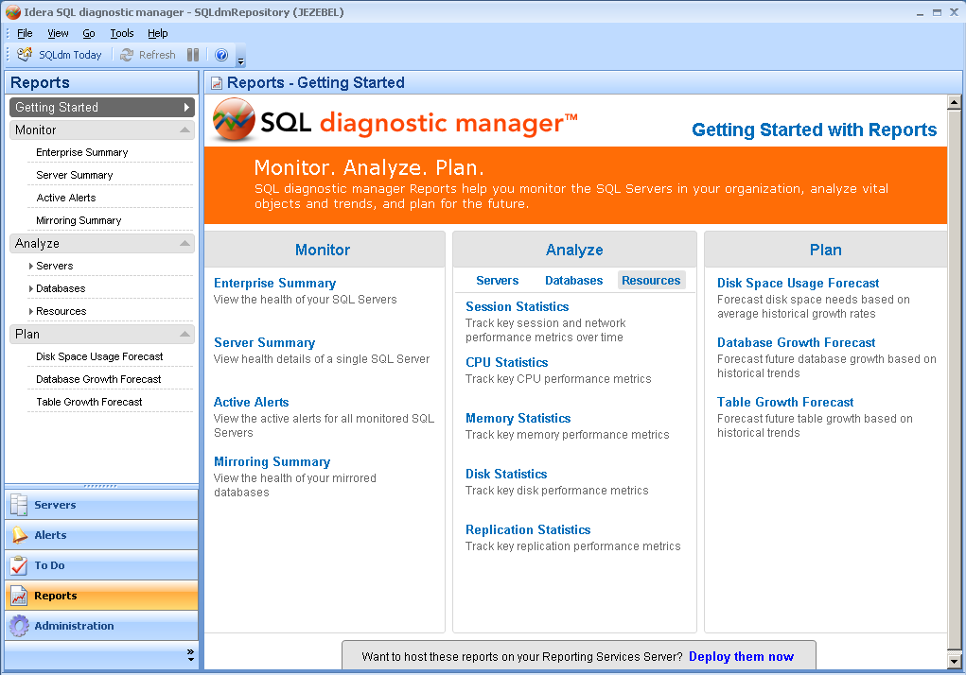

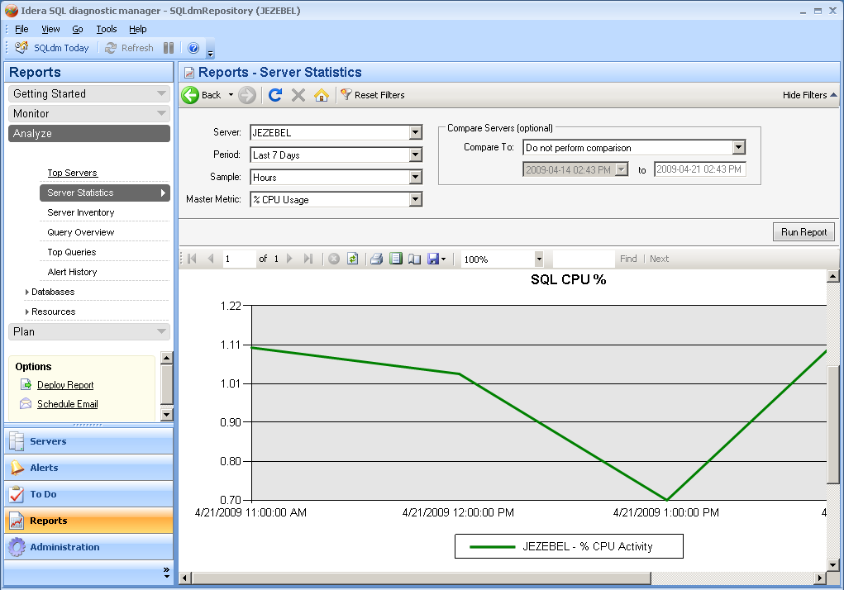

Use Reports to Track Performance
SQLdm Reports allow you to track your SQL Server performance over a set period of time. This allows you to view a long-term resource analysis of your SQL Server instances, which can help you better determine future performance.

Generate a Server Summary report
The Server Summary report provides a detailed overview of the health and performance of a specific SQL Server.
To generate a Server Summary Report:
- Click Server Summary in the Monitor section of the Getting Started with Reports view.
- Click Server and select a SQL Server instance to build the report on.
- Click Start Time to enter the time you want to generate a report on.
- Click Run Report.

Generate a Server Statistics report
The Server Statistics report lets you analyze and compare performance trends across two SQL Server instances.
To generate a Server Statistics report:
- Click Server Statistics in the Analyze section of the Getting Started with Reports view.
- Use the Server drop-down list to select the SQL Server instance to build a report on.
- Use the Period drop-down list to select the time you want to generate a report on.
- Use the Sample drop-down list to set the period of time between each point on the graphs included in the report.
- Use the Master Metric drop-down list to set the type of statistics used to generate the report.
- Use the Compare To drop-down list if you would like to compare these statistics with another server.
- Click Run Report.

Installing SQLdm in a Windows Server 2003 Clustered Environment
The following instructions guide you through the installation of SQLdm in a Windows Server 2003 based clustered environment.

Install SQLdm Services on Cluster Nodes
Adding SQLdm Services allows each cluster node to communicate with the SQLdm Repository and is vital in the monitoring process. The SQLdm services need to be installed on each cluster node.
To install SQLdm services on cluster nodes:
- Log on with an administrator account to the node on which you want to install SQLdm.
- Run Setup.exe in the root of the SQLdm installation kit on the first cluster node.
- Click Install and then click Install SQL diagnostic manager.
- Read the Welcome window, and then click Next.
- Review and accept the license agreement by clicking I accept the terms in the license agreement, and then click Next.
- Accept the default installation folder, or click Change to specify a different folder, and click Next.
- Select the Typical setup type and click Next.
- Select the SQL Server instance and enter a database name for the SQLdm Repository.
- Enter the service account information and click Next.
- Click Install.
- In Windows Services, stop the SQLdm Management Service and set the Startup type to Manual.
- In Windows Services, stop the SQLdm Collection Service and set the Startup type to Manual.
- Repeat all steps on each cluster node. Specify the SQLdm Repository configured in Step 8.
Note | The installations cannot be done concurrently, as the installers will collide when checking the repository. The installations must be done sequentially.

Configure the Cluster Resource Group
Cluster Resource Group settings must be modified to allow SQLdm to recognize the cluster nodes.
To configure the Cluster Resource Group:
- Select a Disk that is in a Cluster Resource Group and create a directory on that disk that will be used to hold local data for the services.
- On the primary node, create the default registry key and add the full data path value under \SOFTWARE\Idera\SQLdm\Default.
- Select a Cluster Resource Group in which you want to define the SQLdm resources.
- Create an IP Address resource for the SQLdm Services. If there is already an existing Network Name in the Cluster Resource Group, then you can skip this step.
  - Create a Network Name resource that will map to the IP Address.
  - Create the Network Name resource and add the IP Address as a dependency.
- Create a Generic Service resource for the SQLdm Management Service.
  - Add the Disk for the shared data as a dependency.
  - Add the Network Name as a dependency.
  - Specify SQLdmManagementService$Default as the name of the service to start.
- After the service is added right-click it and select Properties.
  - Select the Parameters tab and check the Use network name for computer name box.
  - Select the Registry Replication tab and add \SOFTWARE\Idera\SQLdm\Default.
  - Click OK.

- Create a Service resource for the SQLdm Collection Service.
  - Add the Disk for the shared data as a dependency.
  - Add the Network Name as a dependency.
  - Specify SQLdmCollectionService$Default as the name of the service to start.
- After the service is added, right-click it and select Properties.
  - Select the Parameters tab and check the Use network name for computer name box.
  - Click OK.
- In Windows Services, start the SQLdm Management Service resource.
- In Windows Services, start the SQLdm Collection Service resource.

Complete the Cluster Configuration in SQL diagnostic manager
- Use the Management Service Configuration Wizard to re-register the services.
- Start the SQLdm Desktop Client and select the SQLdm Repository. Use the virtual server name for the SQL Server hosting the SQLdm Repository.
- Verify that your configuration displays correctly in the SQLdm Desktop Client.

Installing SQLdm in a Microsoft Server 2008 Clustered Environment
The following instructions guide you through the installation of SQLdm in a Windows Server 2008 based clustered environment.

Install SQLdm Services on Cluster Nodes
Adding SQLdm Services allows each cluster node to communicate with the SQLdm Repository and is vital in the monitoring process. The SQLdm services need, to be installed on each cluster node.
To install SQLdm services on cluster nodes:
- Log on with an administrator account to the node on which you want to install SQLdm.
- Determine the network Name and allocate an IP address for the clustered services.
- Run Setup.exe in the root of the SQLdm installation kit on the first cluster node.
- Click Install and then click Install SQL diagnostic manager.
- Read the Welcome window, and then click Next.
- Review and accept the license agreement by clicking I accept the terms in the license agreement, and then click Next.
- Accept the default installation folder, or click Change to specify a different folder, and click Next.
- Select the Typical setup type and click Next.
- Select the SQL Server instance and enter a database name for the SQLdm Repository.
- Enter the service account information and click Next.
- Click Install.
- In Windows Services, stop the SQLdm Management Service and set the Startup type to Manual.
- In Windows Services, stop the SQLdm Collection Service and set the Startup type to Manual.
- Repeat the previous steps on each cluster node. Specify the SQLdm Repository configured in Step 9.
Note | The installations cannot be done concurrently, as the installers will collide when checking the repository. The installations must be done sequentially.

Configure the Cluster Resource Group
Cluster Resource Group settings must be modified to allow SQLdm to recognize the cluster nodes.
To configure the Cluster Resource Group:
- Select a disk that is configured in the Cluster Resource Group and create a directory on that disk that will be used to hold local data for the services.
- On the primary node, edit the registry and add a new key named Default to the key \Software\Idera\SQLdm. In this key add a string value called DataPath. Set its value to the full path to the data directory created in step 1.
- In the Failover Cluster Management tool, right-click on Services and Applications and select Configure a Service or Application.
  - Select Generic Service.
  - Select the SQLdm Management Service.
  - Enter the network name and IP address for the services.
  - Select the clustered storage that hosts the path defined in step 1.
  - Skip the Registry Replication.
  - Verify the settings and click Next to complete the wizard.
- In Services and Applications, right-click on the newly created service and then on the SQLdm Management Service and take it offline.
- In Services and Applications, right-click on the newly created service and then on the SQLdm Management Service and select Properties.
  - On the General tab, select Use Network Name for computer name.
  - On the Dependencies tab, add the Disk and Name of the service.
  - On the Registry Replication tab, add the \SOFTWARE\Idera\SQLdm\Default\DataPath.
- Right-click on the new services node and then select Add a Resource and Generic Service.
- Select the Collection service from the list of services.
- Select Next and finish out the wizard.
- In Services and Applications, right-click on the newly created service. Select the SQLdm Collection Service and then select Properties.
  - On the General tab, select Use Network Name for computer name.
  - On the Dependencies tab, add the Disk and Name of the Service.
  - On the Registry Replication tab, add the \SOFTWARE\Idera\SQLdm\Default\DataPath.
- In Windows Services, bring the SQLdm Management service resource online.
- In Windows Services, bring the SQLdm Collection service resource online.
- On the last node on which you installed the SQLdm services, use the Management Service Configuration Wizard to re-register the services (Start > All Programs > Idera > SQL diagnostic manager > Tools > Management Service Configuration Wizard).
- Test the configuration from the Management Service Configuration Wizard before finishing the wizard.

Complete the Cluster Configuration in SQL diagnostic manager
Start the SQLdm Desktop Client and select SQLdm Repository. If the SQLdm Repository is clustered, make sure to use the virtual server name for the SQL Server hosting the SQLdm Repository.

